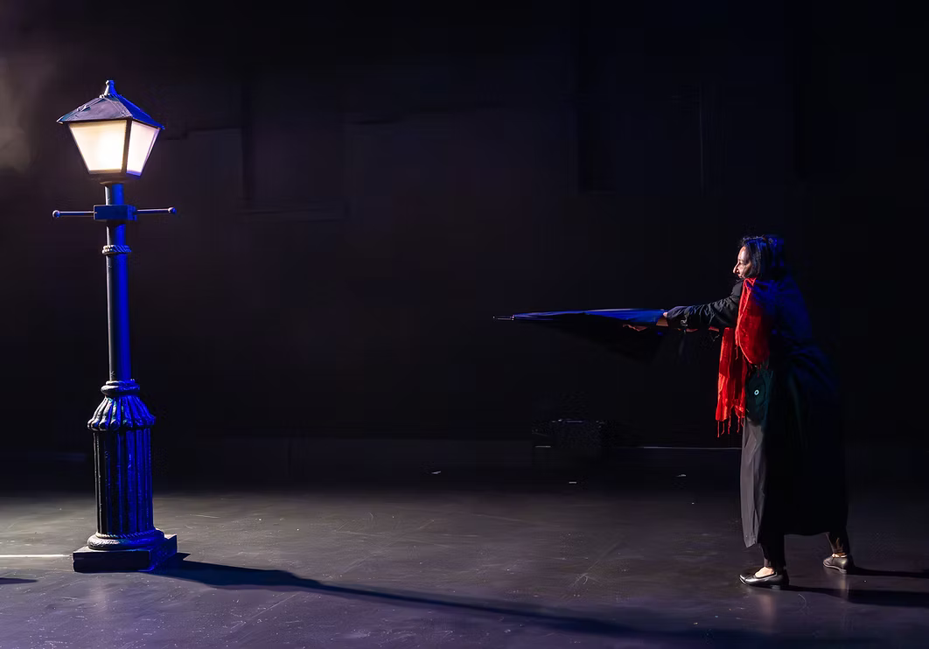

Sometimes It Snows in April

Tottering Biped Theatre

Producer: Trevor Copp artisticdirector@totteringbiped.ca

Show Overview
Sometimes It Snows in April is a simple two-hander. It is blocked for a proscenium layout, and raked audience seating is preferred. Our actors will enter the audience, adequate step lighting is required for actor safety. Our tech needs are minimal, yet quite specific.

Our team is able to be flexible and adjust our requirements, please reach out to discuss any required changes.

Our team travels with 4 people:
- Trevor Copp (Mime)
- Bo Bardos (Soprano)
- Stage Manager
- Lighting Director

Scheduling
We will require 1 full day of technical & rehearsal time prior to the opening of the show. An ideal sample tour schedule would be as follows:

Wednesday
- 4pm team arrives - check into hotel

Thursday
- 9am Load-in/Setup
- 11am Lighting Levels/Sound Levels
- 1pm LUNCH
- 2pm Tech Rehearsal
- 4pm Full Run Through
- 5:30pm Touch ups
- 6:00pm END OF DAY

Friday (opening night)
- 12pm Theatre Access
- 2pm Dress Rehearsal
- 4pm Company Break
- 7:30pm SHOW

Hospitality & Wardrobe
If the company is to be performing more than 2 shows, a washer and dryer shall be provided to launder our costumes.

Please stock the green room with the following:
- Easily accessible drinking water
- 1 package of juice boxes (NOT sugar free, must contain sugar)
- Fruits & Veggies

Set & Props Requirements
Our set requires a park bench and a practical street lamp (with an incandescent bulb, controllable from a dimmer).

Presenter Provides:
- A sturdy park bench
  - Actors will use unconventionally, including placing bodyweight onto the seat back and arm rests.
  - Surface should be checked for splinters
- A practical street lamp - aesthetic appearance must be approved by the director, please send us a photo
- A props table, backstage-left
- A refrigerator somewhere in the building where we can store our perishable food items for use in the show.

Company Provides:
- A piece of black fabric to hang from the back of the bench, masking the gaps between slats.
- All consumable props, including sandwiches, strawberries, and other food items.

Technical Requirements
The tech for this show is quite self-contained. If you are not able to achieve any of the requirements below please let us know. Our stage manager operates the whole show from one laptop. This laptop must be situated in the audience at the back - it cannot be in an isolated sound booth.
Presenter Provides:
- Technical documentation on venue inventory and layout, including a base lighting plot. This must be provided no later than 1 month in advance of the tech day.
- A basic sound system sufficient for some simple audio playback from our QLab computer.
- 2 XLR cables ready for our audio interface at the stage manager position (in the house)
- Projector adequate for the venue, hung from the grid, must cover at least 75% of upstage wall / masking.
- An HDMI or SDI cable routed to the projector, located at the stage manager position in the house
- General house plot with cool fronts and warm tops, warm side/tips
- 4 specials - hung in consultation with the lighting director
- Atmospheric Effects (high end - do not rent these from Long & McQuade)
  - A DMX controlled hazer (Ultratec Radiance or better)
  - A DMX controlled quiet snow machine (Ultratec Silent Storm or better)
    - Snow bags/practical snow work if you have a quiet alternative!

Company Provides:
- A laptop running QLab and ETC EOS with an ETC Nomad dongle.
- An audio interface for audio output

Atmospheric Effects (Haze and Snow)
Our ideal version of the show includes DMX controlled haze and snow machines. However these are both flexible, depending on the constraints of your space.
Haze Machine  The hazer should be hung from the grid for even distribution. If your fire system is set off by haze, please advise us if any alternatives are possible (ie fire watch). If no solution is available, we will proceed without haze. | Snow Machine  Our preference is to work with a snow machine as long as the venue is large enough (ie fly system) to muffle the sound. If you feel a “silent” snow machine will be too loud in your space, we will project the snow instead.

Lighting Requirements
Please provide your house lighting plot to our team no later than 4 weeks in advance of our tech day. The lighting director will reach out with plans for the location of 4 specials (all ETC Source 4s or similar).

We are willing to work with your existing venue house plot to keep things simple. If possible, please provide your venue plot in Vectorworks or DWG format.

Seating Requirements
We require some reserved seating for actors to pass through the rows. Please provide us with your seating layout in advance and we will indicate which seats need to be blocked/removed.

